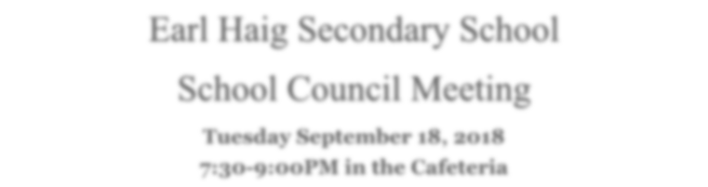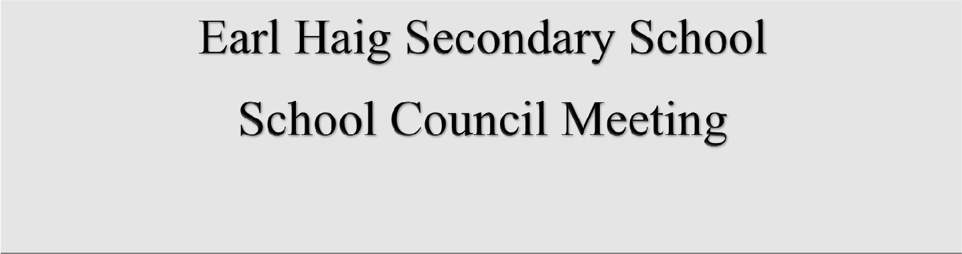

Tuesday September 18, 2018 7:30-9:00PM in the Cafeteria

The EHSS School Council is pleased to welcome you to our
Annual General Meeting
to kick off the 2018-2019 school year.

Agenda
- Welcome and Introductions
- School Council Annual Report - Susan & Phi
- Introduction of the 2018-19 School Council Executive
- Principal’s Update & Introduction of Vice Principal’s – Renata Gonsalves
- Student Activity Council Update –SAC President, Michael Samoilov
- Time Management Tips
- Adjournment

A l l P a r e n t s a n d G u a r d i a n s a r e W a r m l y I n v i t e d t o A t t e n d !

